Globalcode jHome 1.0
Oracle Innovation Award 2011

jHome is an open-source platform for home automation based on Java EE 6 and Glassfish 3 developed by Globalcode. Starting with U$ 100,00 you can do the hardware yourself* and control your first lamp or any device that is plugged on a wall socket using our funny Home Automation API.
*no soldering needed, no advance electronics knowledge required

You can control a lamp using EJB, Servlet, WebService and also EJB Timer Services for scheduling your house electronics objects! Jhome is also a different way to learn Java EE resources.

jHome = open-source software & hardware + Java EE + home automation

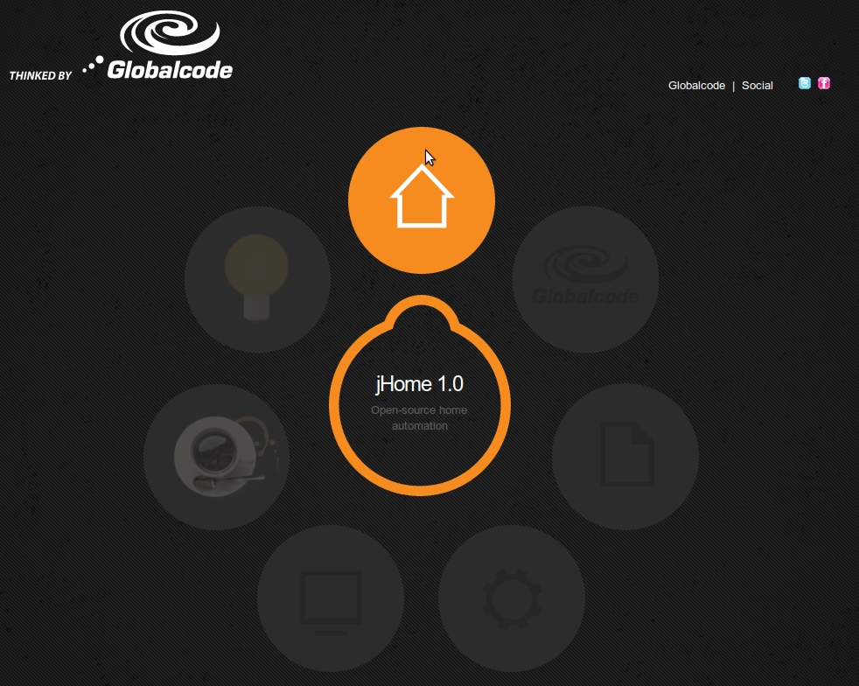

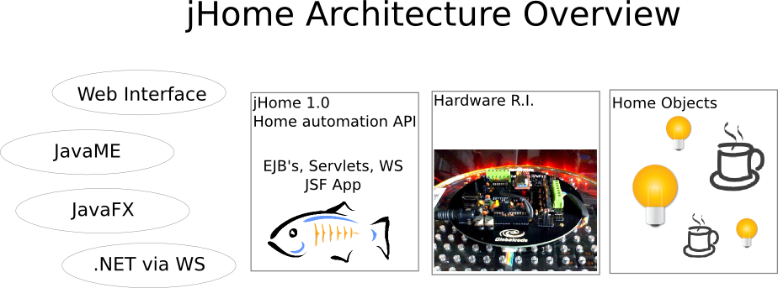
We are providing complete information and source code:

- jHome API to control lamps, RGB leds, scheduling and webservices wall jacket control;
- Sample JavaFX client application
- Sample JavaME client application
- Sample .NET client application
- Reference Implementation Hardware Schema with Arduino or Oracle Spot;
- Reference wireless communication with bluetooth
- Documentation and schematics
- Support forum
- Source-code under Apache license

Lamp Control / RGB Led Control

Using this Web interface with AJAX, jQuery you can send asyncronous requests to Glassfish Servlet to change the color of RGB light or turn on / turn off a lamp.

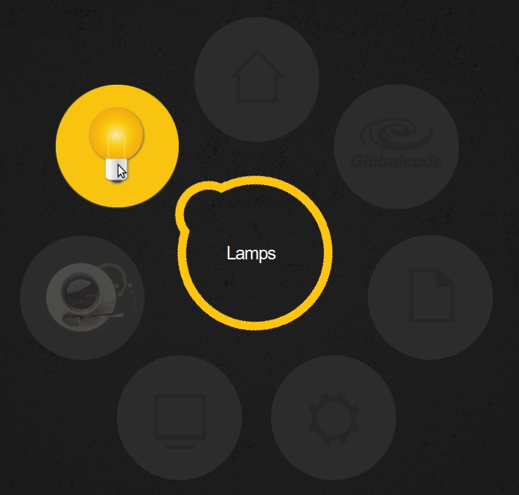

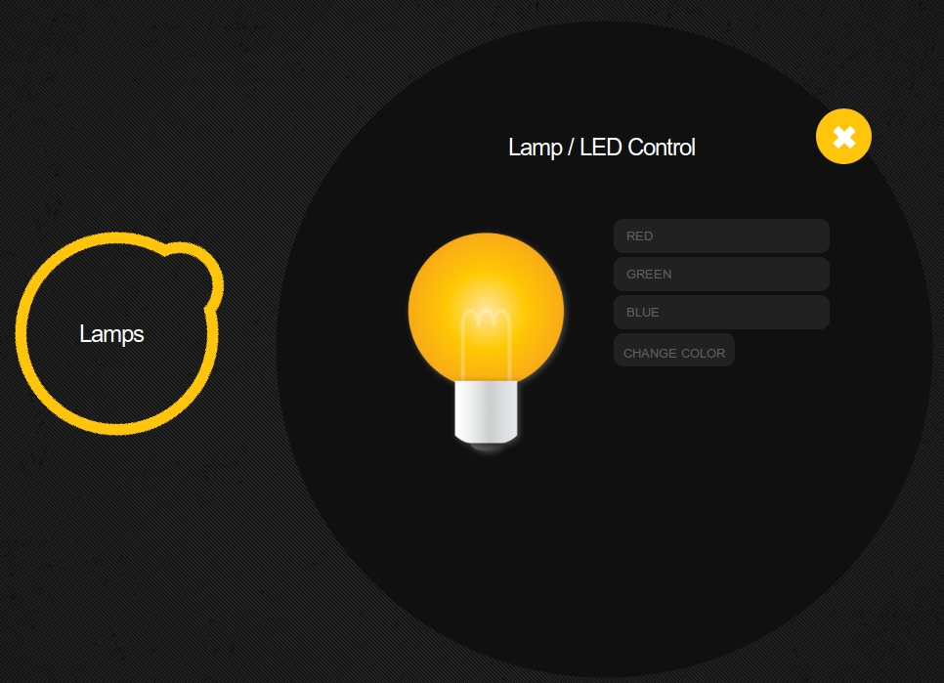

Coffee Machine Control

The coffee machine control is very useful for software! We provide EJBs with timer services for you to schedule your coffee not just helping to turn on, but also helping to turn it off!

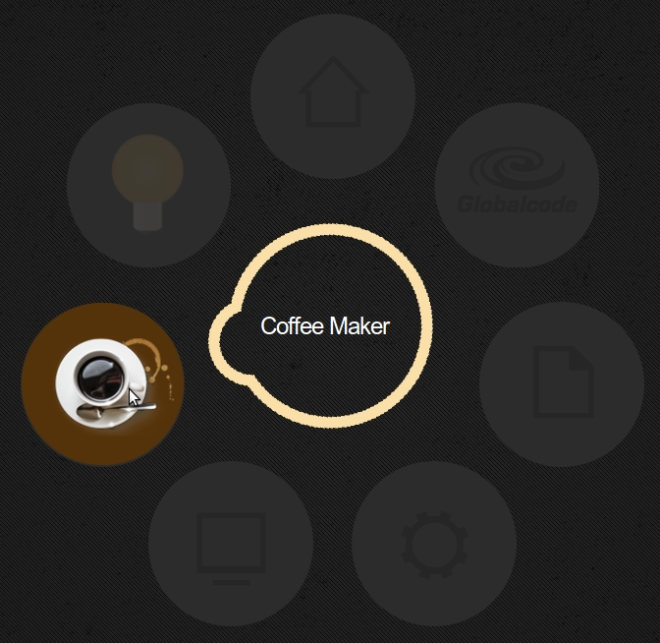

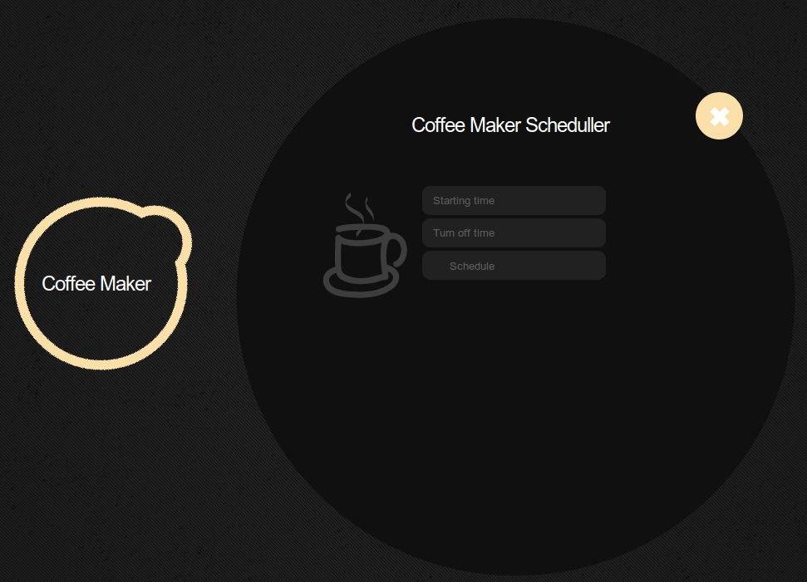

Twitter Integration

A special part of API allows developers to integrate Twitter with their home objects, you can send messages from twitter to your house to control lamps, leds and so on!

Robot Control

For JavaOne conference we prepared a special demo with Java EE controlling a robot that can bring us a beer, for example, during the show!

Hardware reference implementation

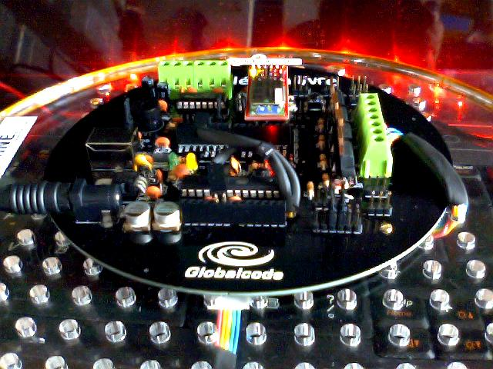
The hardware can be implemented using any kind of microcontroller board / device such as Arduino (popular and cheap), Oracle Spot (more robust), PIC, BasicStamp and so on.

We are providing two different implementations:

- Arduino based: is easy to find around the world but requires some C code.
- Sun Spot / Oracle spot based: nice and robust electronic prototyping platform but not available yet all around the world. No C code, just Java with Oracle Spot!

The amount you are going to spend depend on how many things you want to control in your house. For the “Hello World” project controlling wall jacket you will need:

- Arduino board / Oracle Spot kit
- Relay board
- Bluetooth module

